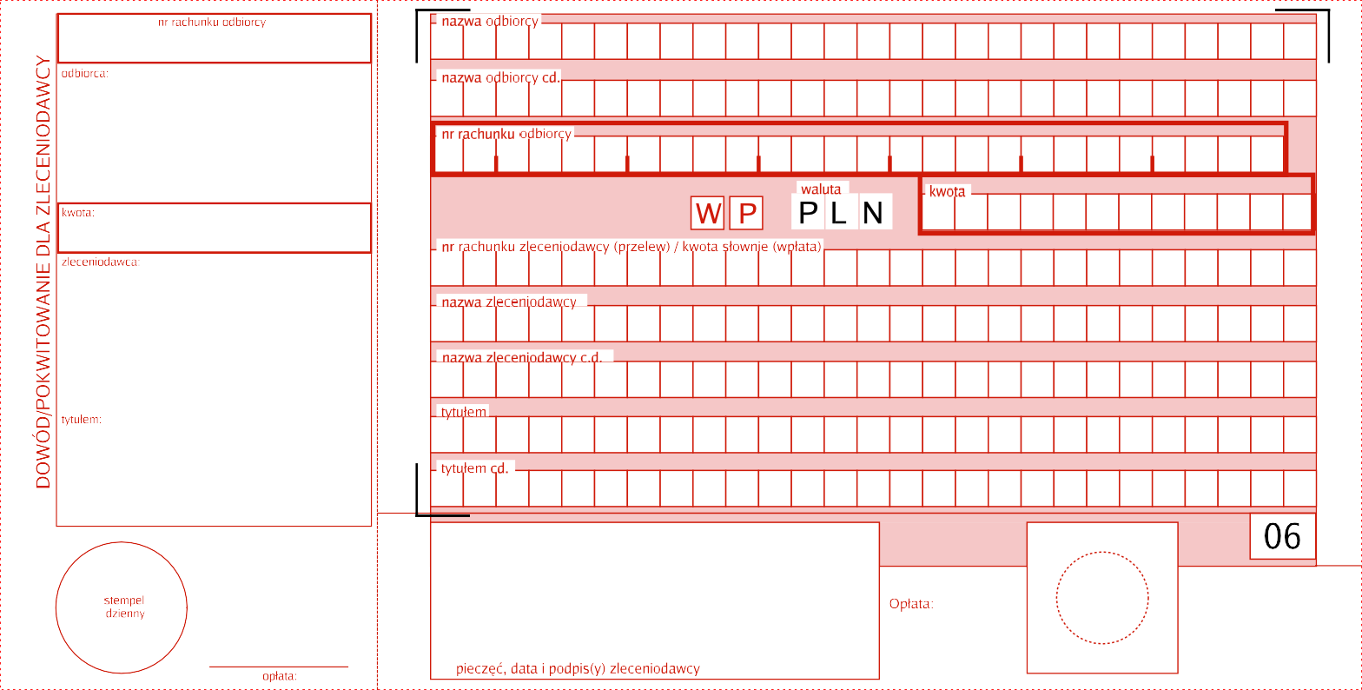

79880500090000343420080001

P A R A F I A

R Z Y M S K O K A T O L I C K A

P W

Pa r a f i a r z y ms k o k a t o I i c k a p w. Na r o d z e n i a NMP w

J a z o ws k u

.

N A R O D Z E N I A

N M P

W J A Z O W S K U

7 9 8 8 0 5 0 0 0 9 0 0 0 0 3 4 3 4 2 0 0 8 0 0 0 1

X

Da r o wi z n a n a c e I e k u I t u

r e I i g i j n e g o

D A R O W I Z N A

N A

C E L E

K U L T U

R E L

I G I J N E G O









|  |  |  |  |
| --- | --- | --- | --- |
|  |  |  |  |